Go Redmen!
Due to the RLHS Boys’ Basketball Team earning a
position in sectional competition and to accommodate
the large number of parents who will be traveling to
Chetek for the game, we have modified previously
scheduled Parent/Teacher Conferences scheduled for
Thursday, March 12, 2015 at RLHS & RLMS.
We feel Parent Teacher Conferences are a valuable opportunity for parents and teachers to share the progress that children have made in their educational career. Therefore, the new schedule for Parent Teacher Conferences at RLHS & RLMS will be:
Thursday, March 12, 2015 (1-3:20 pm) and Tuesday, March 17, 2015 (3:30-6 pm)
Teachers will welcome you in their respective classrooms during the above scheduled times. Feel free to choose the date/times that best accommodate your schedule. We apologize for any inconvenience this may cause your family.
A fan bus to the Boys’ Basketball Sectional Game is being
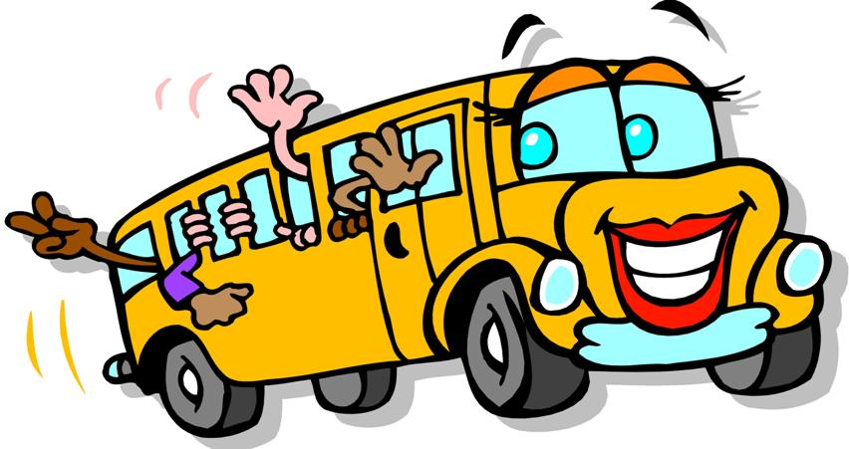
offered to Rib Lake High School students and community
members. The cost is $10 which includes the bus ride and
admission to the game. Middle school students and
younger may ride with a parent chaperone. The bus will
leave at 3:15 p.m. on March 12th from the RLHS parking
lot. Please call Lori in the high school office if you are
interested in riding the fan bus to Chetek since 30 paid riders are required by 1 pm on March 11th to secure a bus for the trip.

Feel free to contact me if you have any questions/concerns regarding the above information.
Rick Cardey, Middle/High School Principal

